Introduction to JoeBot The SSU_CS Chatbot

Salem State University | Beifang Yi

CSC340

Devin Gleason-Lambert

2013

Contents

**Introductions** 2

**IRC Primer** 3

**What is IRC?** 3

**Why IRC?** 3

**How?** 3

**Setting up JoeBot on your Server** 9

**Interacting with JoeBot** 9

**Welcome** 9

**Addressing JoeBot** 9

**Say** 9

**Factoids** 9

**Adding Factoids** 9

**Telling about factoids** 9

# **Introductions**

tehej

# **IRC Primer**

## **What is IRC?**

IRC is the Internet Chat Protocol, it is used mostly for group communication on the web, usually more stripped down than most internet clients you may be used to. IRC has a larger technical community than you might be used to so it makes for a great place for coders to hang out and find answers to their questions.

## **Why IRC?**

Well IRC like I said has a more technical community, sure there are topics on a lot of different things but for example most of the common programming languages each have a channel of at least 300 active members at most times. Also most of the individuals logged on are those that are in the field and there experience is indispensable if they are willing to help you with your problem. Lastly IRC is not like other chats like you may be used to like AOL, Facebook, ICQ, etc. For example, you probably don’t want to ask the person who posts pictures of cats on your wall if they can check over your work on a recursive call you just coded.

## **How?**

As of now SSU has a Computer Science channel on the freenode IRC server that you can join right now. To start all you have to do is navigate to <http://webchat.freenode.net>

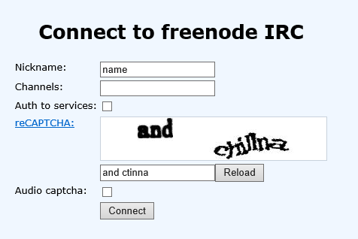

You should land at this page, and it is pretty self-explanatory, you need to pick a name, and fill in the Captcha.

After this you will be brought to the landing page.

The first thing you need to do is register your nick, short for nickname. But make sure that your nickname is not already registered when you logged in.

cid:image002.png@01CE1533.B1BF1B10

If this happens you will need to pick a different nick by using the syntax ***/nick newName***

Once you have a nick that is unique, you can register by running command

***/msg NickServ register password email***

After this your email should get a command to confirm your registration that you must copy and paste into the IRC client.

Next time when logging in now you will not need to register but instead just use your new nick, and once logged on identify yourself as that registered nick by using the command

***/msg NickServ identify password***

And from here you are free to join any channel you like, for example let’s start by joining the department channel.

***/join SSU_CS 201j***

The syntax here is /join channel password    Where the password is optional and usually not used for most channels.

If you are curious to check out some other channels some of the ones I can recommend are ##C ##C++ ##Java #algorithms ##CS  and #Programming, if you would like to search for a channel by keyword just use the command

***/msg alis list *searchterms\****

Make sure you include the ** and what your searching for inbetween.

In closing, overall IRC is just another tool for us in the information field that could use a place to discuss sometimes difficult topics. I hope you all give it a try and come by the #SSU_CS channel. If you have any questions feel free to respond to this email and I will try to help as best I can.

# **Setting up JoeBot on your Server**

JoeBot is a portable application, meaning there is no installation necessary. He is hardcoded with the nick JoeBot always, and he is hard coded to join the Channels *ssu_cs* and *ssu13cs_seniorproject* and no others.

All that needs to be done is take your zipped version of JoeBot, extract him to a folder on the server you plan on running him on.

Once extracted navigate to …\JoeBot\Src\ And double click on the StartJoeBot.bat batch file, this will start JoeBot.

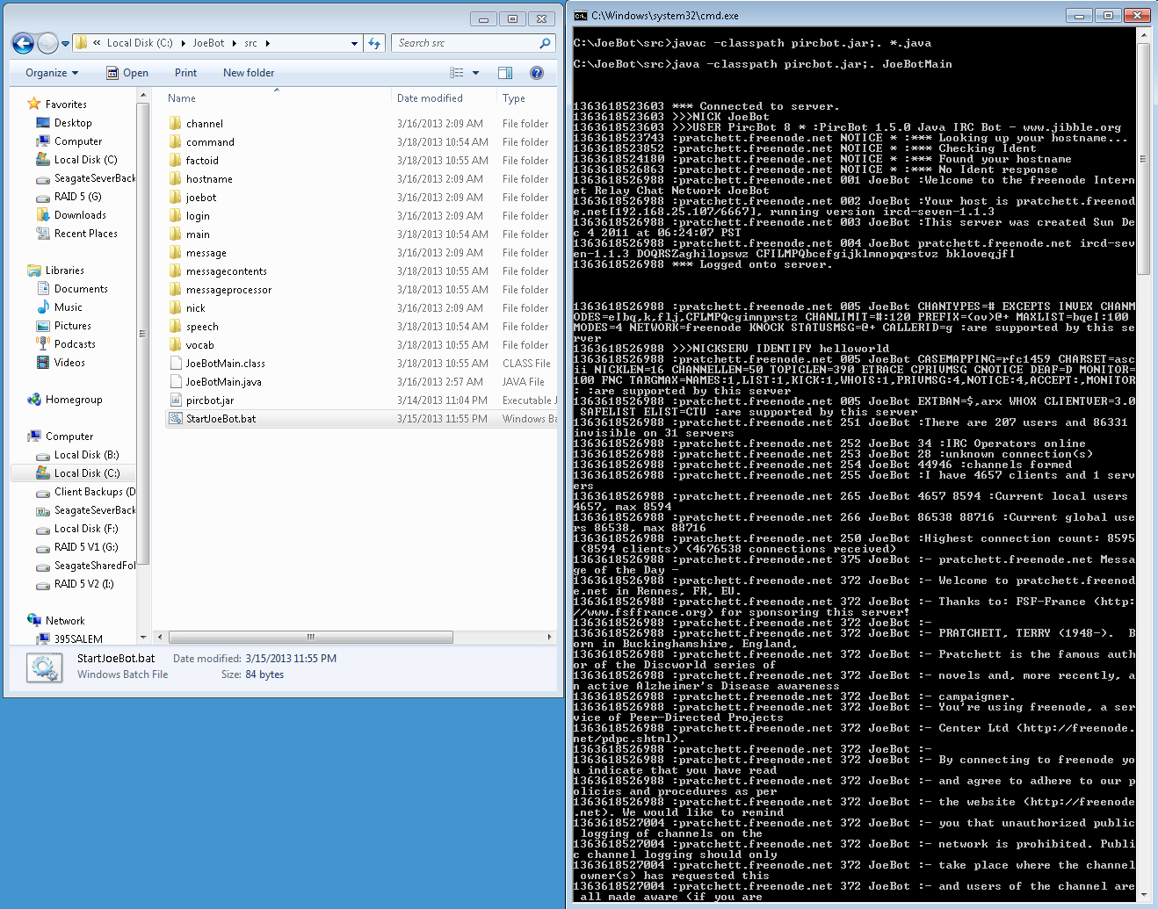

Now what you should see in your IRC client focused on SSU_CS is



# **Interacting with JoeBot**

You can interact with JoeBot in a few ways

## **Welcome**

 When you join a channel, JoeBot will welcome you in.

## **Addressing JoeBot**

You can address JoeBot in one of three ways,

JoeBot

JoeBot,

JoeBot:

## **Say**

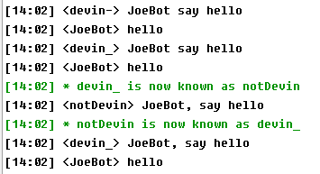 If your nick is devin_ or devin-, You can direct JoeBot what to say

## **Factoids**

You can call JoeBot to recall factoids from his factoids database.

## **Adding Factoids**

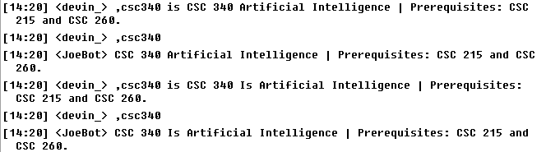 You can add and update factoids to JoeBot’s factoids database.

## **Telling about factoids**

You can tell JoeBot to tell someone or yourself about a certain factoid.